**Overview**

The Box App lets you access your documents stored in your Box account from your iPhone and iPad. Box associates specific apps installed on your mobile device to create or edit documents stored in your Box account – Docx files open in Microsoft Word, PPTx files open in Microsoft PowerPoint, Xlsx files open in Excel, etc.

Box is ideal for making quick, simple edits from your mobile device, and posting those files back to your Box account for sharing and collaboration.

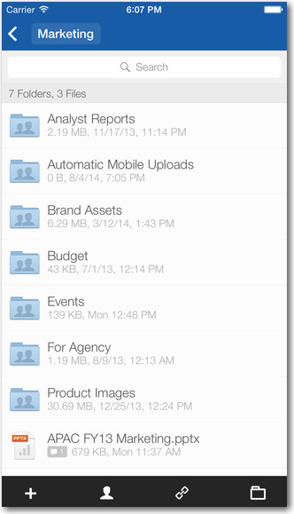

The Box App lets you create new or edit existing files straight from your mobile device. Compatible files include Word, PowerPoint, Excel, Google files, etc.

**Set-Up and Configuration**

Box can be downloaded/installed from the Apple App Store.

* 1. Download the Box for iPhone / Box for iPad App.
  2. Install the App.
  3. Once the Box App has been installed, configure your Box account that the App will be accessing. Be sure to select **Single Sign-On** for accessing your CAA Box account.
  4. Log into your Box account using your CCA email address. Once the account login information has been entered, a pop-up window will ask for permission to access your Box account. Allow the Box App to access your Box account.

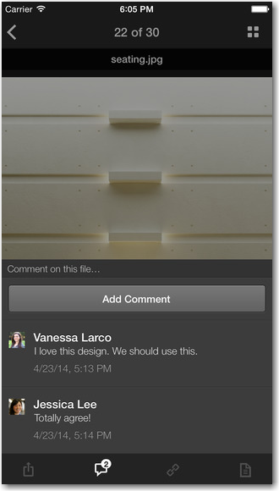

In addition to creating new files and editing existing files, the Box App lets you Add Comments to files in your Box account.

**FAQs**

* **What file types are compatible?**

All traditional Microsoft Office programs – Word, PowerPoint and Excel – as well as Adobe PDF files can be opened with the Box App.

* **Once I save a file, does it automatically appear on Box? Is it saved as a new file within a folder or does it just replace the existing version of the file?**

After you’ve opened and revised a document using the Box App, saving it puts the file back in Box as a new version, replacing the existing version automatically (it does not save it as a new file). As usual, you can access older versions in the version history.